K. Z. S. Science College, Bramhani, Kalmeshwar

SINCE 1993

COLLEGE LIBRARY

LIBRARY
(Established in the Year – 1993)
The library of this college established in the year 1993, offers undergraduate leading to the B.Sc. degree, awarded by the RTM Nagpur University. Library is a heart of institutions. The Library is central and common to all the academic activities of the college. It is provide to place of study. About the 3684 books covering Math’s, chemistry, physic, botany, Zoology, computer science and General discipline are available. It is open form 9.30am. To 4.30 pm.
Library service
- Library is computerized.
- Provided Xerox & Internet facilities.
- More number of latest Editions purchased.
4. Special Reader Service was provided to the Ex- student, members, alumni and others.
5. Clipping file: Under this programme Newspaper cuttings regarding the Institution are gleaned and filed.

Library at a Glance
 | General Books
Year | Text Book |  | Reference Book |  | Practical |  | Total
 | G | Amount | G | Amount | G | Amount | Book | Amount
Book Till in12-13 | 1009 | 118410 | 549 | 123663 | 8 | 950 | 1566 | 243023
2013-2014
2014-2015 | 20 | 4259 | 41 | 21962 |  |  | 61 | 26221
Total | 1029 | 122669 | 590 | 145625 | 8 | 950 | 1627 | 269244

 | Donated Books
 | Text Book |  | Reference Book |  | Practical |  | Total
 | D | Amount | D | Amount | D | Amount | Book | Amount
Book Till in2012-13 | 123 | 6079 | 150 | 12372 |  |  | 273 | 18451
2013-2014
2014-2015
Total | 123 | 6079 | 150 | 12372 |  |  | 273 | 18451

 | MRP Books
Year | Text Book |  | Reference Book |  | Practical |  | Total
 | MRP | Amount | MRP | Amount | MRP | Amo | Book | Amount
Book Till in2012-13 | 45 | 11192 | 121 | 108500 | 3 | 1109 | 169 | 120801
2013-2014
2014-2015
Total | 45 | 11192 | 121 | 108500 | 3 | 1109 | 169 | 120801

 | UGC Books
Year | Text Book |  | Reference Book |  | Practical |  | Total
 | UGC Books | Amount | UGC | Amount | UGC | Amount | Book | Amount
Book Till in2012-13 | 601 | 95821 | 1003 | 453131 | 11 | 8904 | 1615 | 557856
2013-2014
2014-2015
Total | 601 | 95821 | 1003 | 453131 | 11 | 8904 | 1615 | 557856

Book Till in 2014-15
Total Book
G | D | MRP | UGC | Total
1566 | 273 | 169 | 1615 | 3623
61 |  |  |  | 61
1627 | 273 | 169 | 1615 | 3684

Book Amount Till in 2014-15
Total Amount
G | D | MRP | UGC | Total
243023 | 18451 | 120801 | 557856 | 940131
26221 |  |  |  | 26221
269244 | 18451 | 120801 | 557856 | 966352

Journals
Year | Journals | Amount | Periodicals | Amount | Newspaper Per day | Amount | Newspaper Weakly | Amount
2004-05 | 3 | 2508 |  |  | 3 | 3240
2005-06 |  |  |  |  | 3 | 3240
2006-07 | 4 | 1970 |  |  | 3 | 3240
2007-08 | 6 | 2080 | 1 | 480 | 3 | 3240
2008-09 | 4 | 1970 | 1 | 480 | 3 | 3240
2009-10 | 4 | 1970 | 1 | 720 | 3 | 3240 | 1 | 416
2010-11 | 4 | 1970 | 1 | 780 | 3 | 3600 | 1 | 416
2011-12 | 11 | 20000 | 1 | 840 | 3 | 3600 | 1 | 416
2012-13 | 4 | 2500 | 1 | 900 | 3 | 3600 | 2 | 676
2013-14 | 4 | 2500 |  |  | 3 | 3600 | 2 | 780
2014-15 |  |  |  |  | 3 | 3600 | 2 | 936
Total | 44 | 37468 | 6 | 4200 | 33 | 37440 | 9 | 3640

1. Teaching Staff Information
1. Dr. Vikas. S Borkar (librarian)  Designation: Librarian (Since 1/12/2003)  Qualification: M. Lib, SET, MPhil, Ph. D | 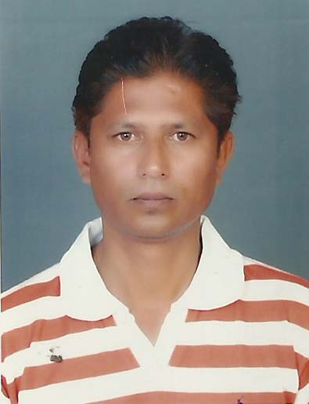
Research Work:
Date of Ph.D degree awarded: 6/7/2011
Research area: Library and information science
Ph. D. Topic: “Online Services of Indian Government Portals : A Critical Study”

Area of Interest (Research): information science
Publications
Papers in International Journal: 00 National Journal: 06
Papers in Conferences: 14
Books Published: 00
Ph. D Students: 05
Research Project/s: 1 MRP funded by UGC during 2011-2013 of Rs. 85000/- (Completed)

2. Non- Teaching Staff Information
Sr. No. | Name | Designation | 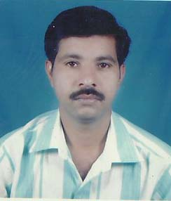
1. | Mr. P.N. Mankar  Qualification B.A B.lib | Library. Attendant  (Since 1/09/1997)

Following Research Scholars are doing Ph. D research work under the guidance of Dr. V. S. Borkar.
Name of the Student | Topic of Research | Date of Registration | Name of Guide
1. Mr. jayant Meshram | Content analysis of social scientist journal during 1972-2013 | Ph.D.(Cell)/RRC/social science /Jan -2013/1702  2.1.2014 | Dr. V.S. Borkar
2. Miss. Swhetal D 1Sawtkar | Study of university libraries in India | Ph.D.(Cell)/RRC/social science /Jan -2013/1666  2.1.2014 | Dr. V.S. Borkar
3. Miss. Shurti S. Manohare | Growth and development of college libraries under the Gondia Education society Gondia : A study | Ph.D.(Cell)/RRC/social science /Jan -2014/1182  24.7.2014 | Dr. V.S. Borkar
4. Mr. Shard V. Padhye | Study of university libraries of veterinary and Animal sciences in India | Ph.D.(Cell)/RRC/social science /Jan -2014/1172  24.7.2014 | Dr. V.S. Borkar
5. Mr. Umesh .G Harde | Database Creation of book publishers in India : An analytical study | Ph.D.(Cell)/RRC/social science /Jan -2014/1174  24.7.2014 | Dr. V.S. Borkar

**************************************************************************************

